Food Donor App

1. Overview

Food Donor aims to reduce food wastage by enabling people to donate food, which those in need could receive through our app. This app promotes Sustainable Development Goal 2 - Zero Hunger.

2. System Summary

(I) Hardware and Software Requirements

Requires a smartphone with an Android operating system (OS). The minimum Android version should be **7.1.2** and above to avail all the features in the application. To download and use the functionalities of the Food Donor mobile app, you require an Internet connection in your mobile.

(II) User Access Levels

There are two types of roles in Food Donor application.

1. Guest User

2. Registered User

1. Guest User

Guest user is one who access and uses the Food Donor application without registering in the application.

2. Registered User

Registered user is one who registers himself/herself in the Food Donor application by filling the registration form. Registered user can Donate or Receive food and post comments/feedback.

3. How to download the application

Food Donor application can be downloaded by going to the following GitHub page and downloading apk file.

4. Guest User – Privileges

* View Homepage.
* View all Donor’s and Receiver’s list.

Homepage –

After launching the app Homepage will be displayed.

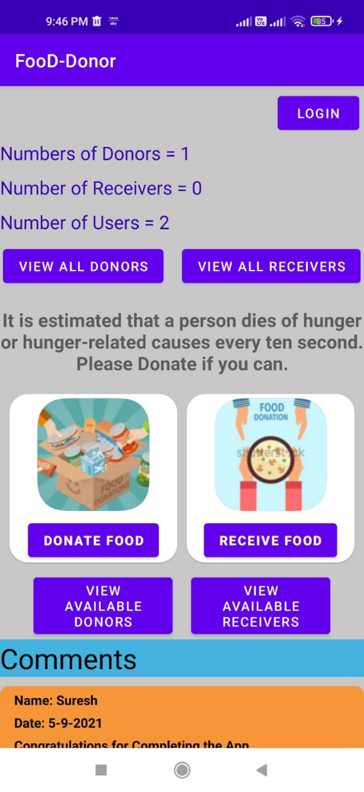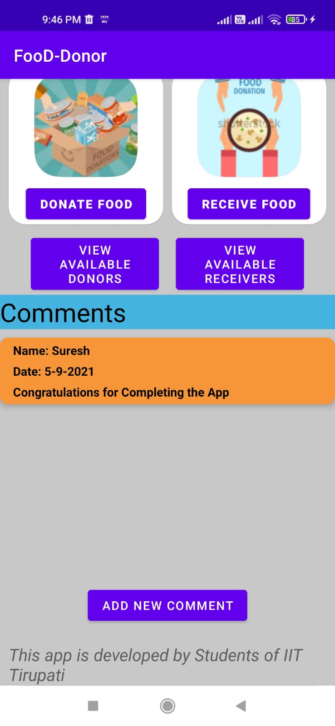

Donor and Receiver List –

On Click of **VIEW ALL DONOR’S** or **VIEW ALL RECEIVER’S** displays the below pages containing list of Donor’s or Receiver’s.

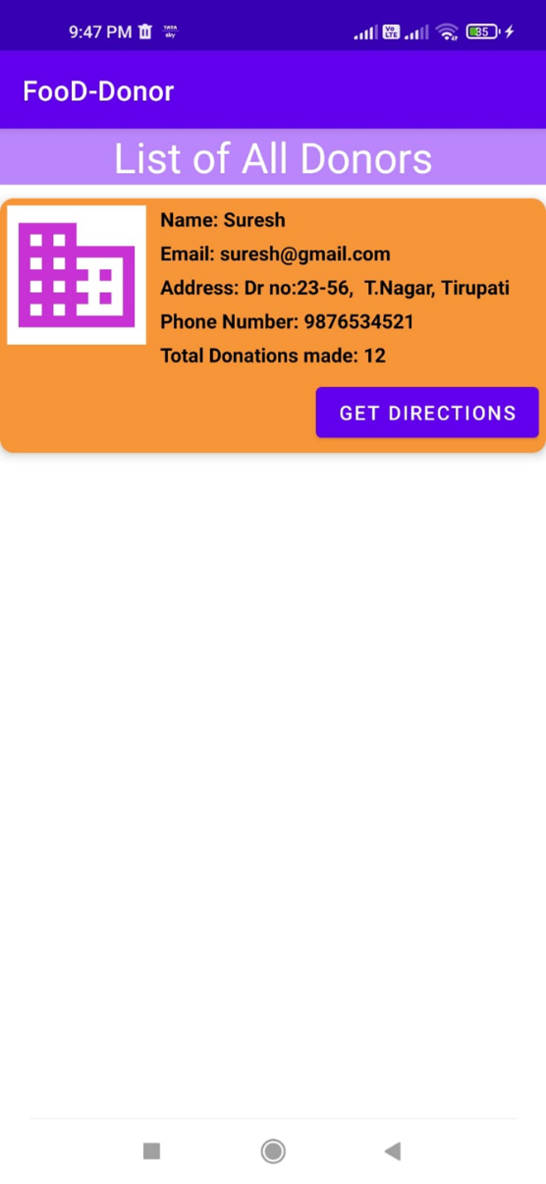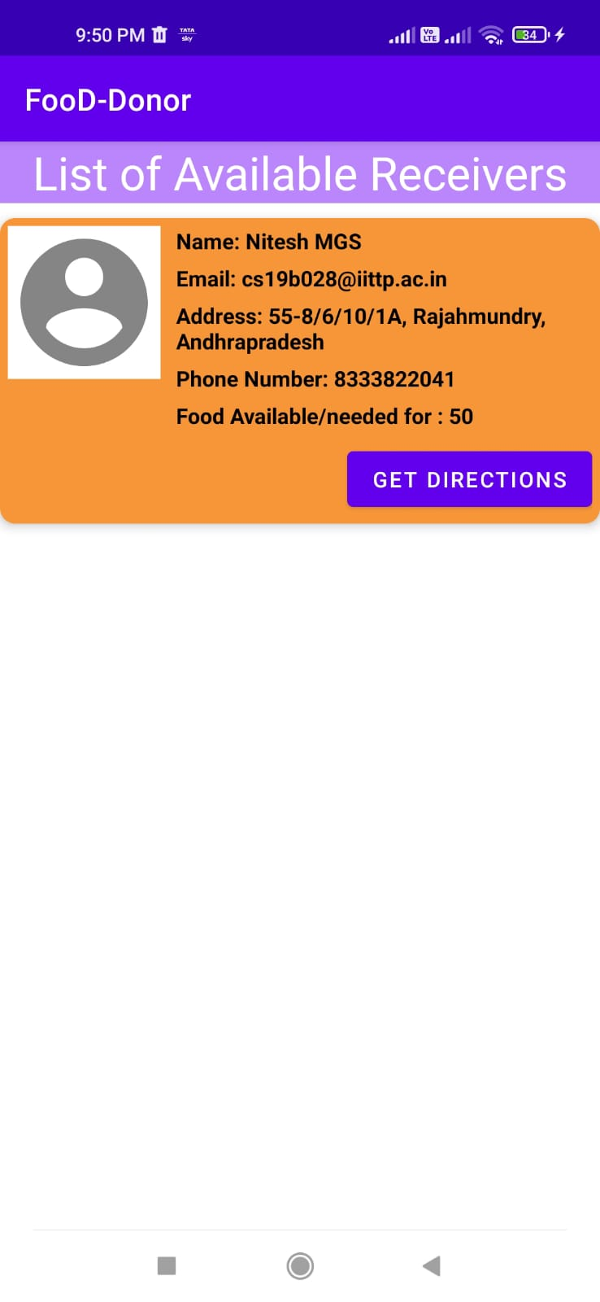

5. Registered User – Privileges

* View Homepage.
* View all Donor’s and Receiver’s list.
* Donate or Receive food.
* Add Comments or Feedback.

Homepage –

After launching the app Homepage will be displayed.

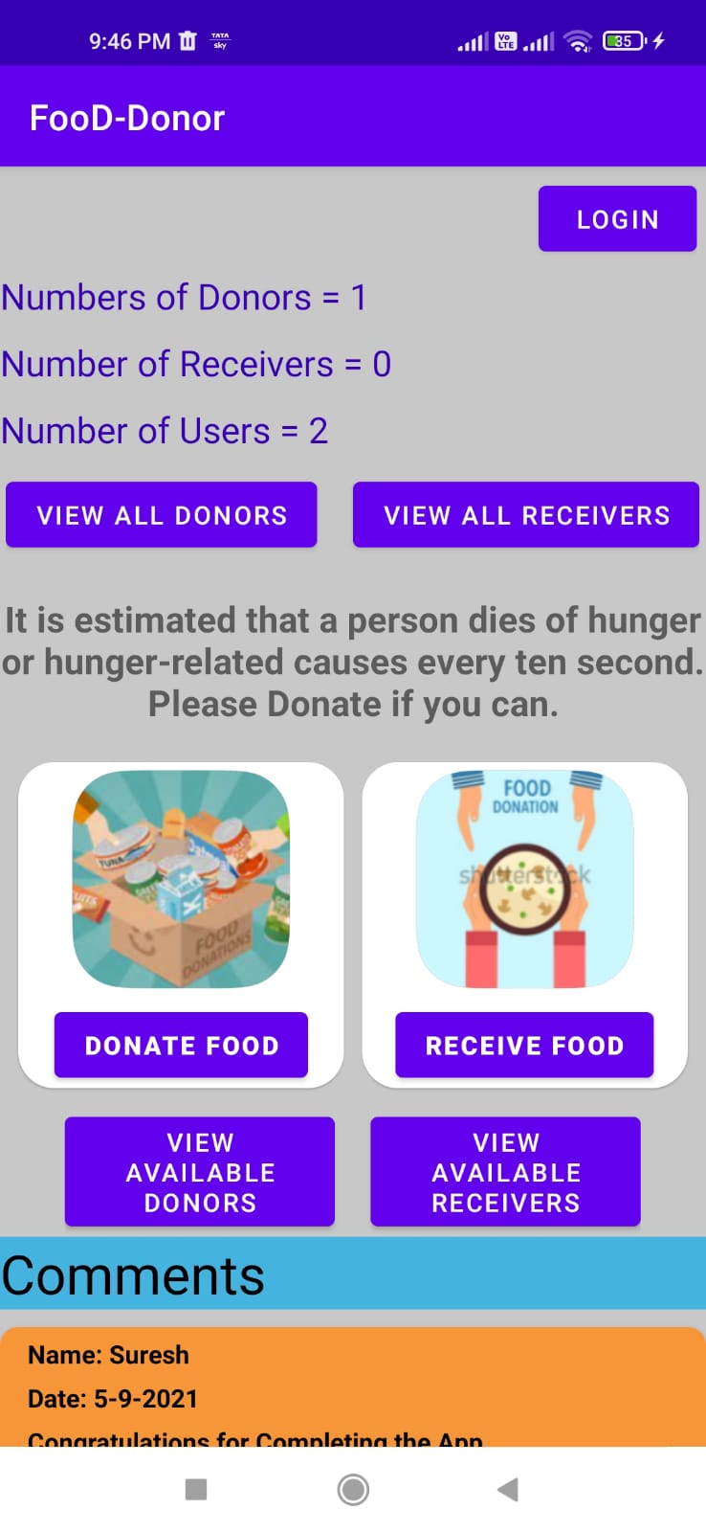

Donor’s and Receiver’s List -

On Click of **VIEW ALL DONOR’S** or **VIEW ALL RECEIVER’S** displays the below pages containing list of Donor’s or Receiver’s.

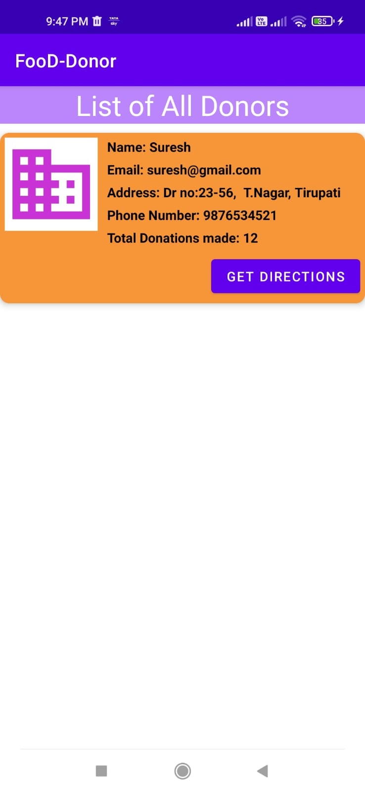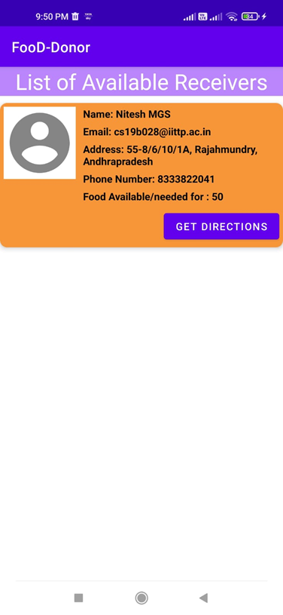

Donate or Receive Food –

On Click of **DONATE FOOD** or **RECEIVE FOOD** takes you to any of the following pages respectively where the required details have to be filled in order to either Donate or Receive food.

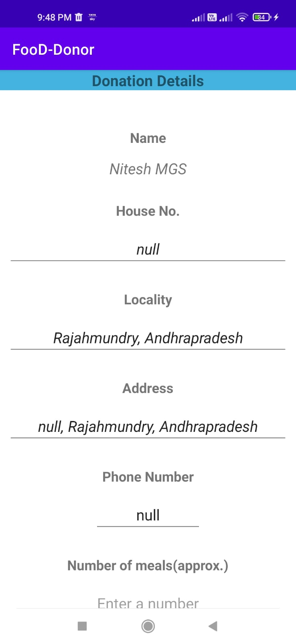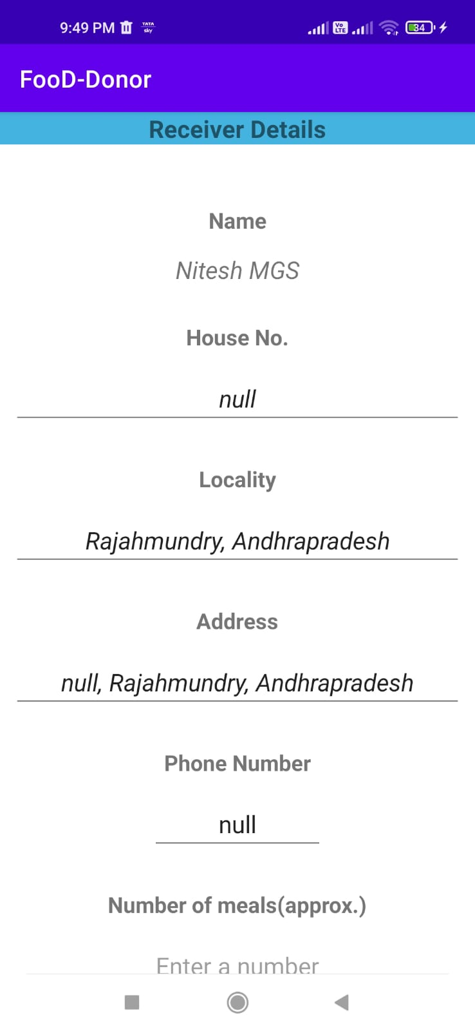

Add Comments or Feedback –

On Click **COMMENT** button, user can post comments or give feedback.

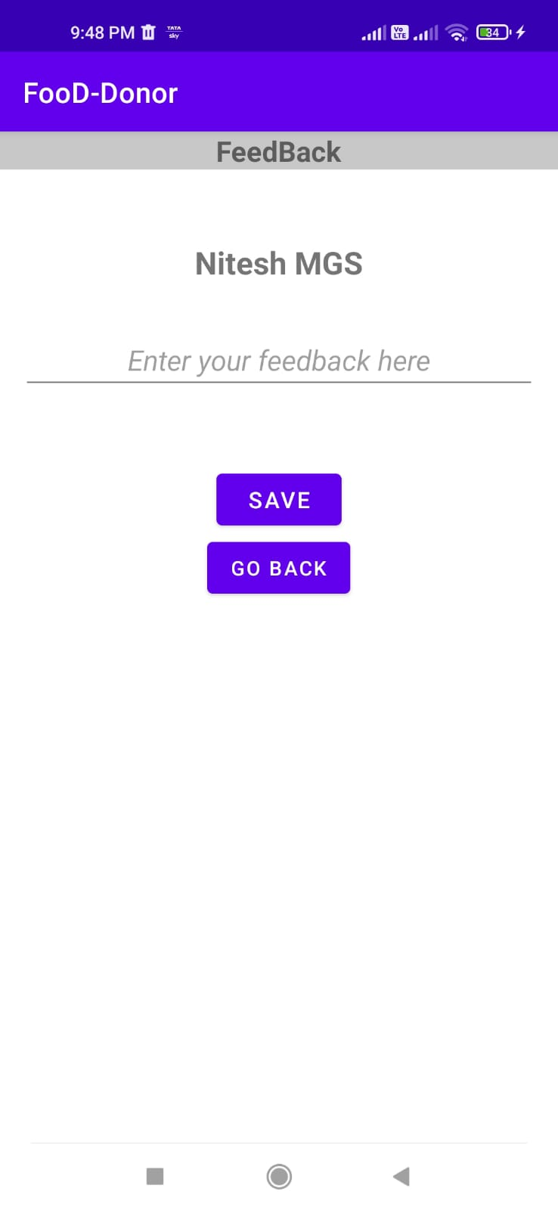

This project was contributed by CS19B013 – Vaibhav Gelle, CS19B016 – Yashwanth Ganna, CS19B028 – Nitesh MGS and CS19B049 Poorna Syama Sundar